**Date – 10/09/2015:**

1. A function propTrace to plot the propagation on the a-sigma grid.
2. Spikemonitor is on for all the groups/layers and the number of layer is 10.
3. Neuron_multiply is implemented as a for loop running the network n times.
4. Delay is added to initial_burst_time to center the window.
5. A plot showing propagation trace with wi = -30, neuron_multiply = 100: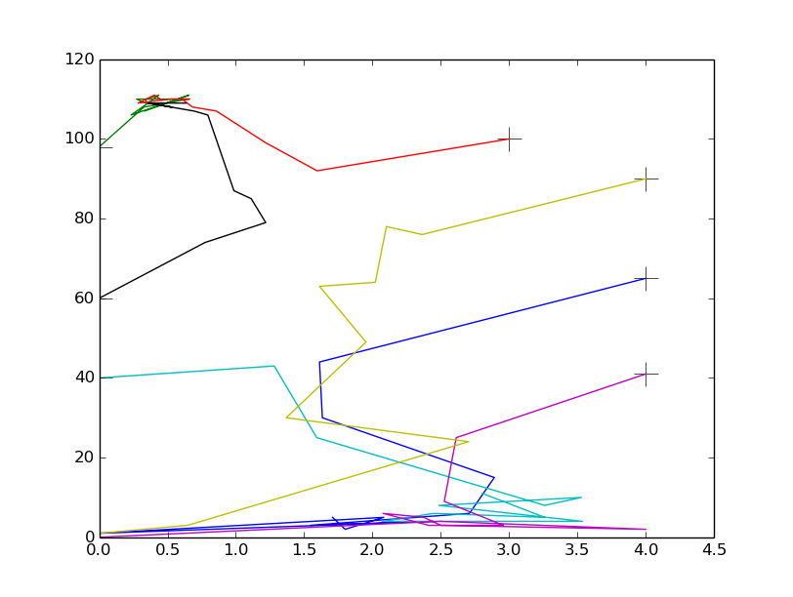
6. Propagation trace with wi = -90, neuron_multiply = 100: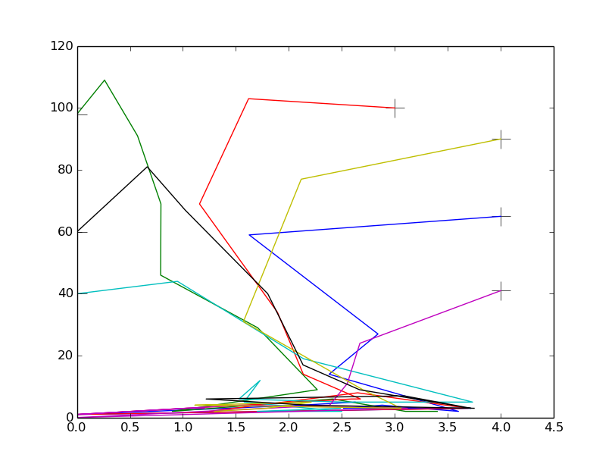

**Date – 11/09/2015:**

1. Implemented propTrace inside fp_vs_Inh function.  
   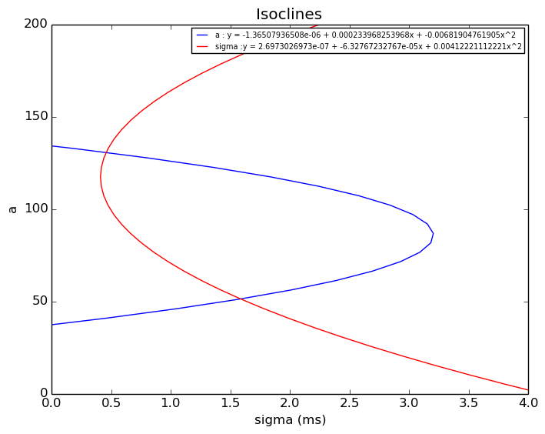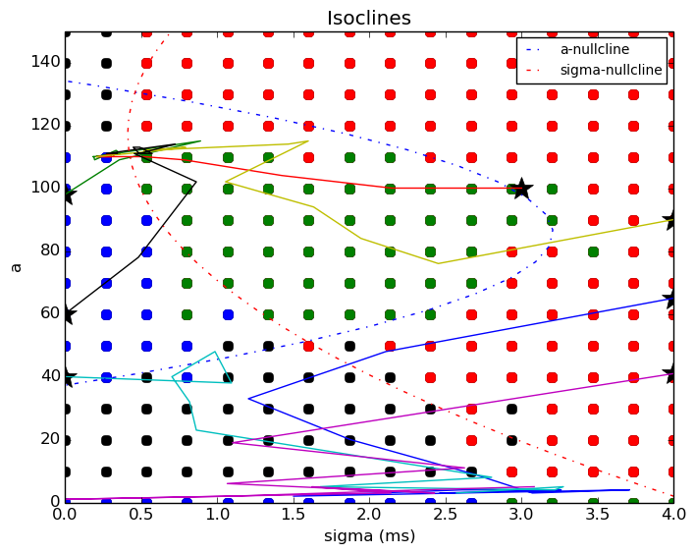
2. Neuron_multiply and inhibition weight are taken as input parameters from fp_vs_Inh
3. Below are plots showing isoclines and propagation from few points.
4. In the plots increase in inhibition is from 0 to -100 with neuron_multiply 50.

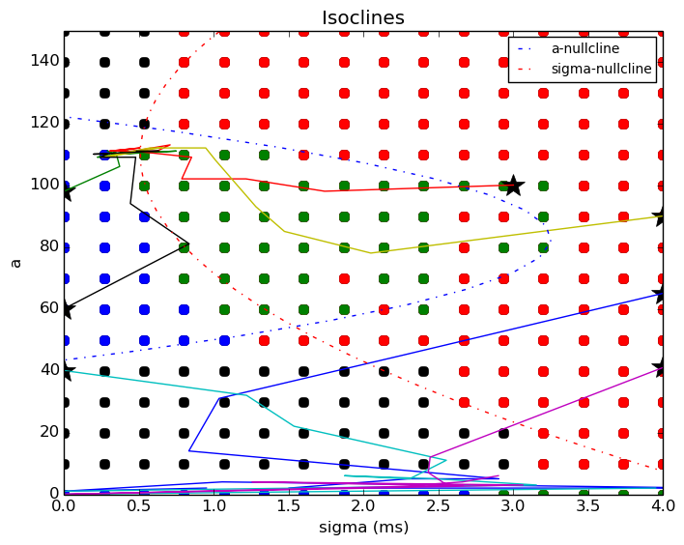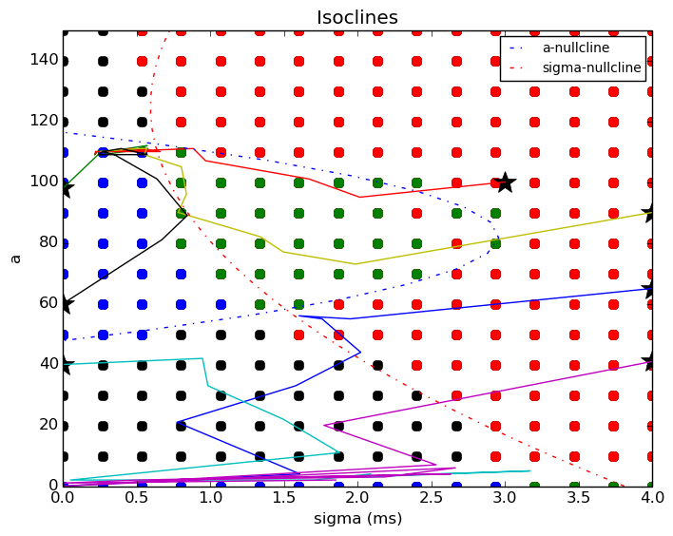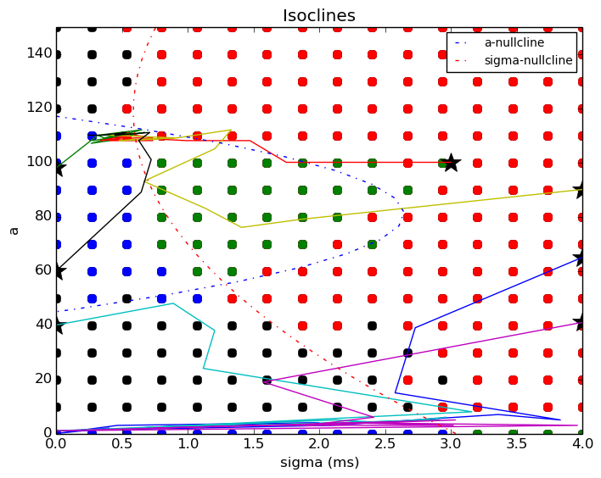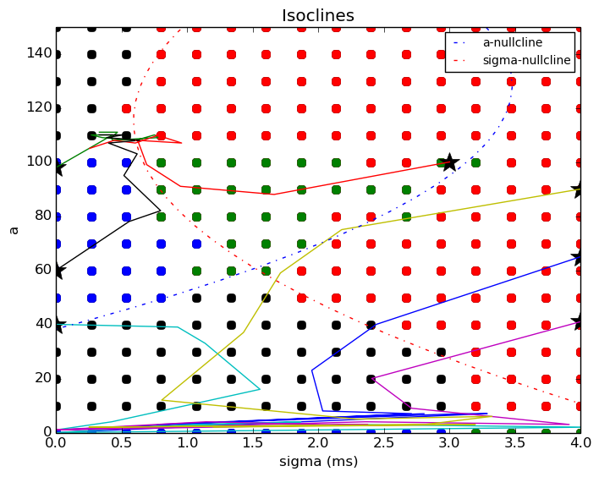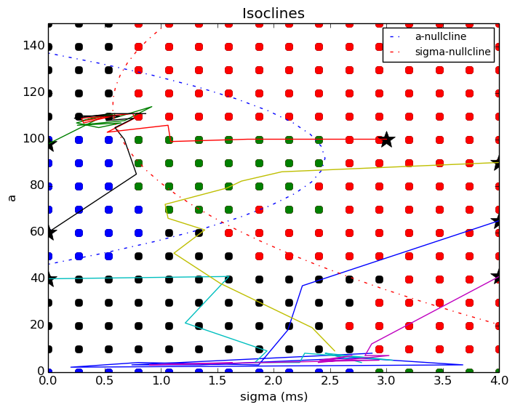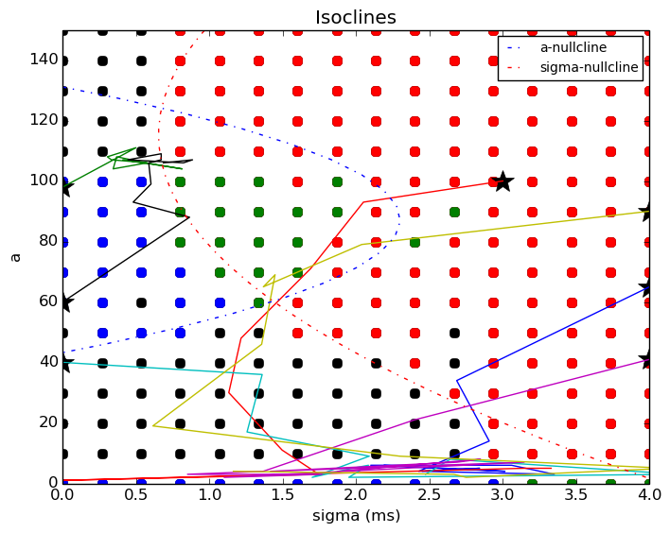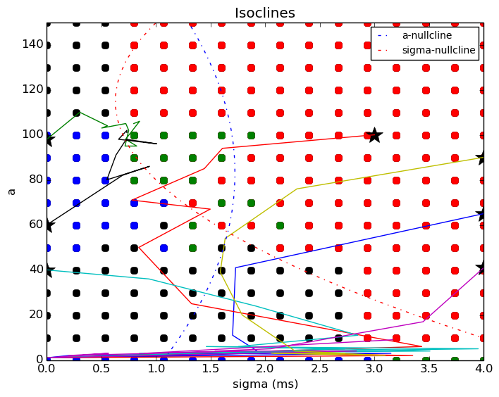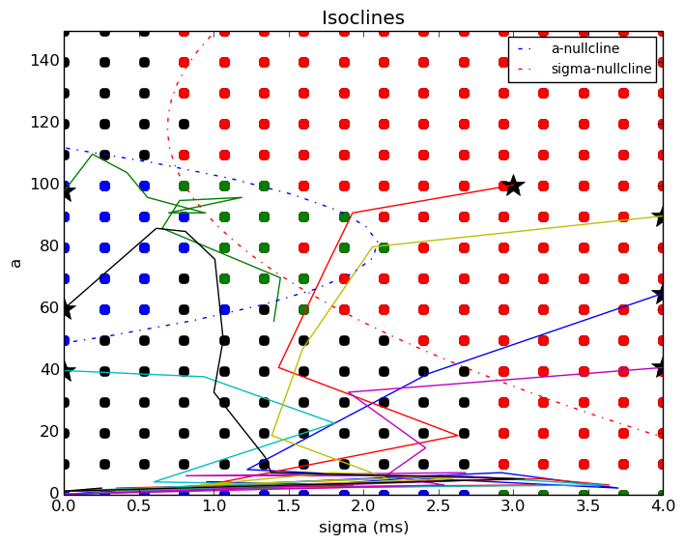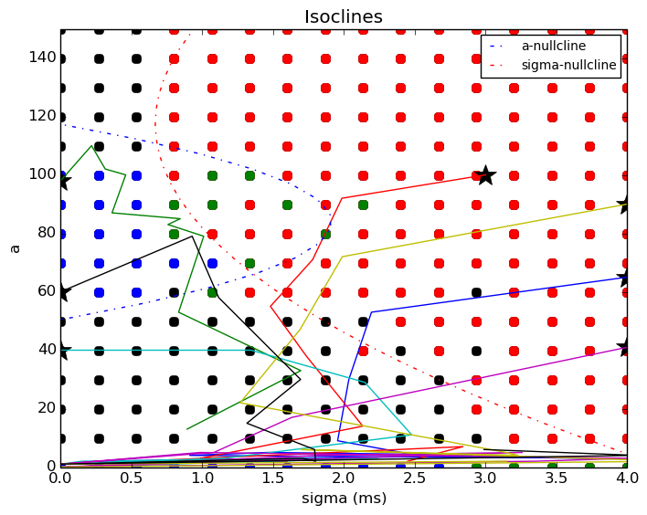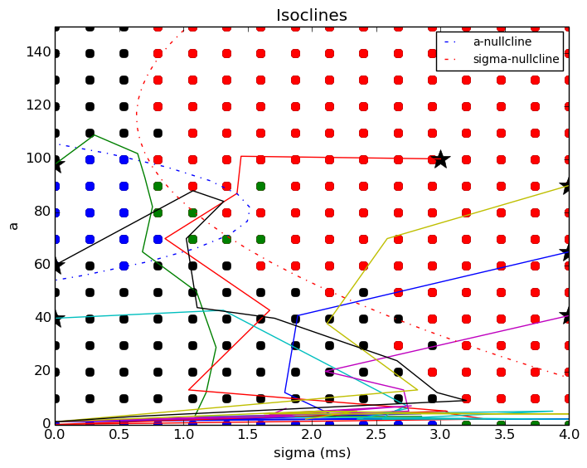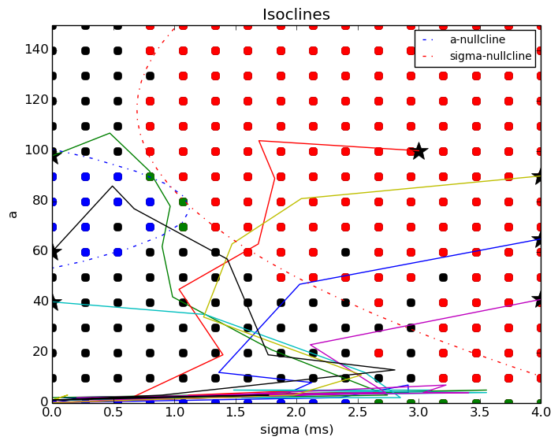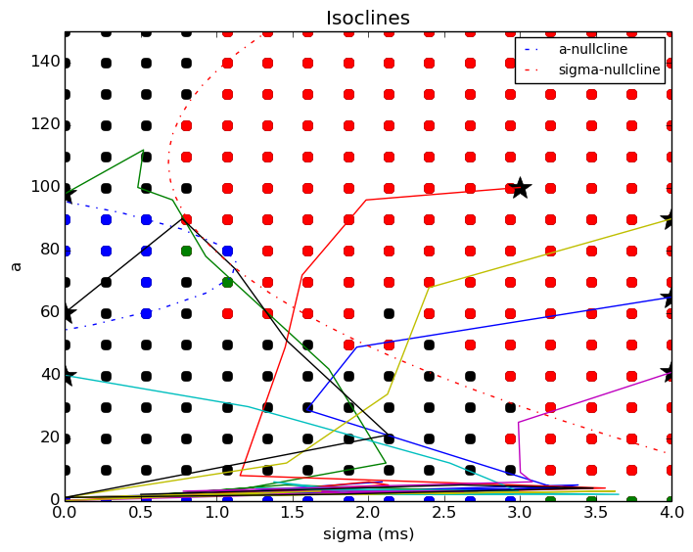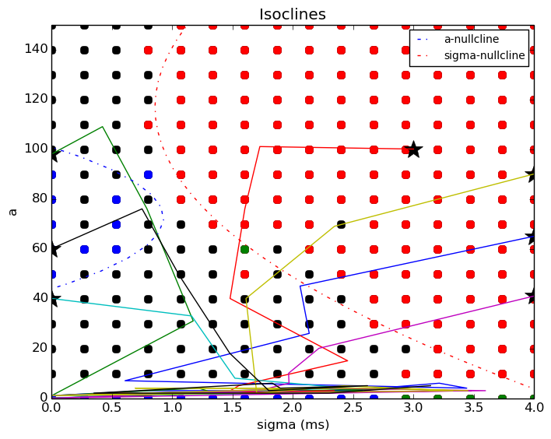

**Date – 13/09/2015:**

1. To check for balance of excitation and inhibition previously, EI-FFN was created. It was found that inhibition in EI-FFN only affected the spike count which was evident from the a-isocline moving leftwards as inhibition increased. This movement of a-isocline is similar to the case when neurons per layer ‘ w’ is changed.
2. The behavior is completely noise driven and noise parameters like number of noisy neurons, proportion of excitatory and inhibitory noisy neurons, rate of inhibition and excitation will be investigated.

**Date – 14/09/2015:**

1. In the functions fp_vs_inh and propTrace input parameters were changed from params.wi to params.noise_inh_rate.
2. Inhibition can be increased by either increasing the proportion of inhibitory neurons, by increasing the weight of inhibition or by increasing the rate of inhibition.
3. The inhibition rate increases the incoming inhibitory current by the following formula.  
   noise_mu = noise_neurons * (noise_exc * noise_exc_rate - noise_inh * noise_inh_rate ) * psp_peak * we  
   where noise_mu is the mean noise current to every neuron in the network except the input group, noise_exc & noise_inh are the proportion of excitatory and inhibitory neruons, 0.88 & 0.12 respectively.
4. Below are plots with increasing frequency of inhibition from 2 to 20 Hz for 12% of the neurons which are inhibitory.
5. 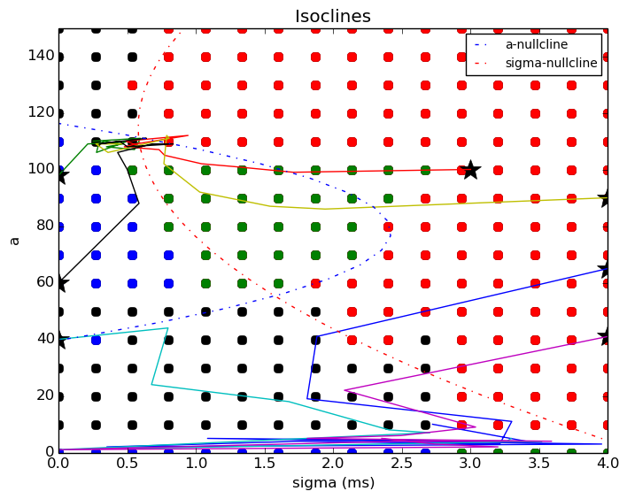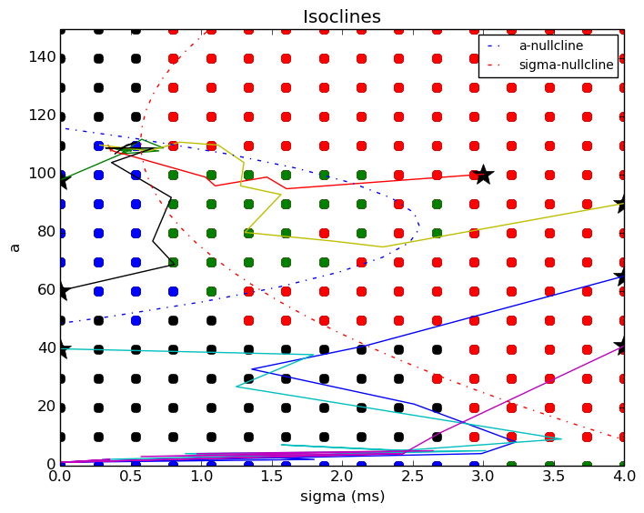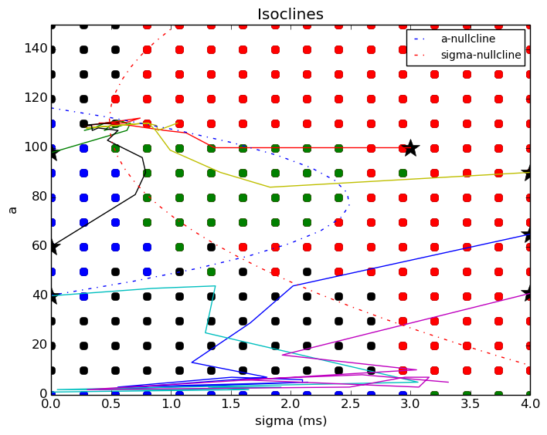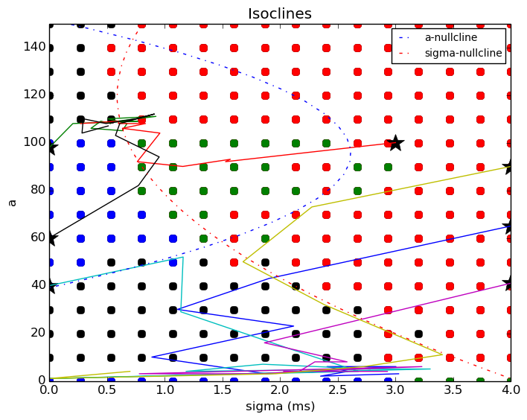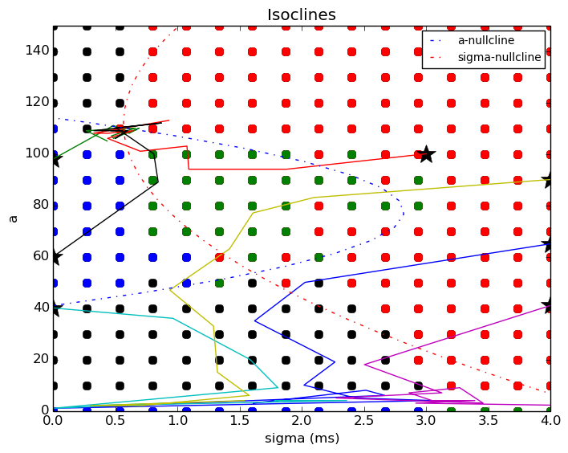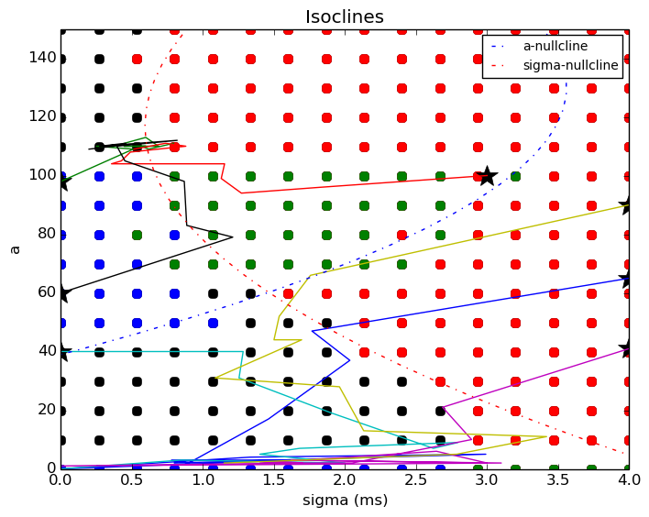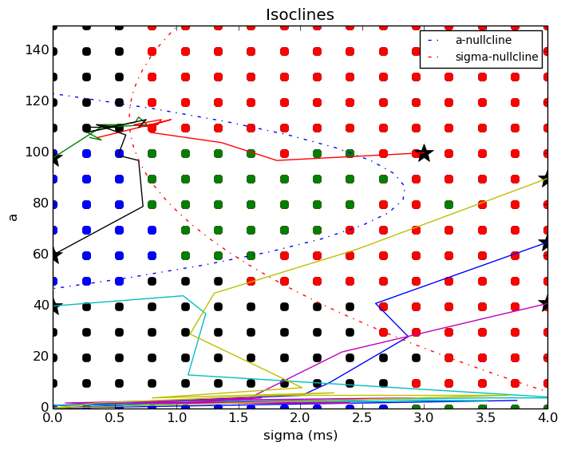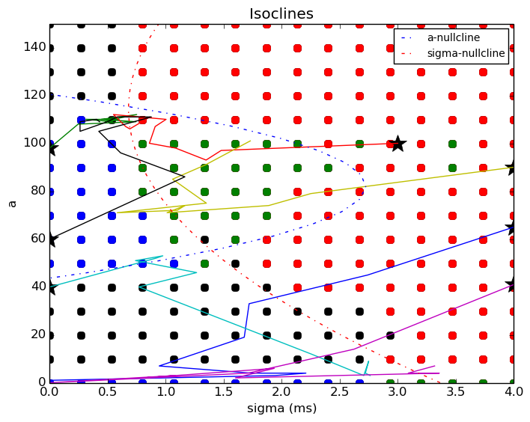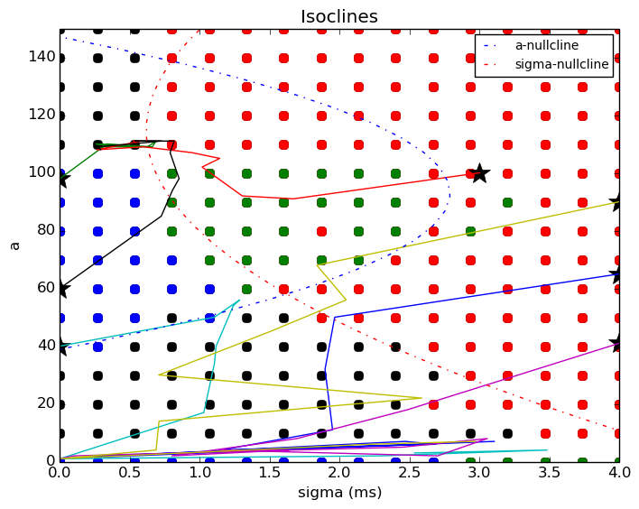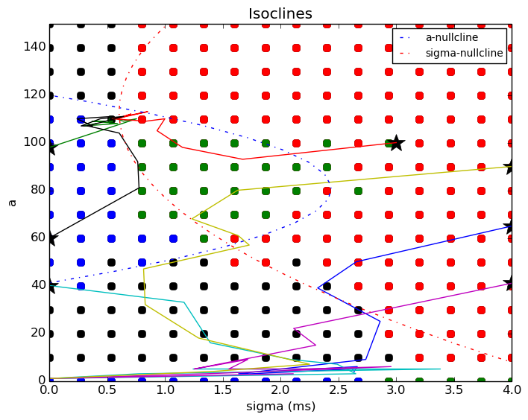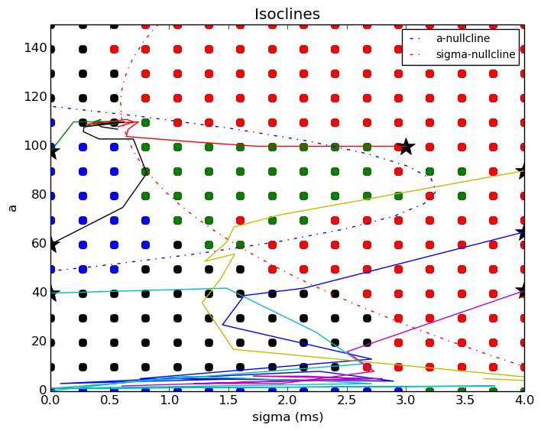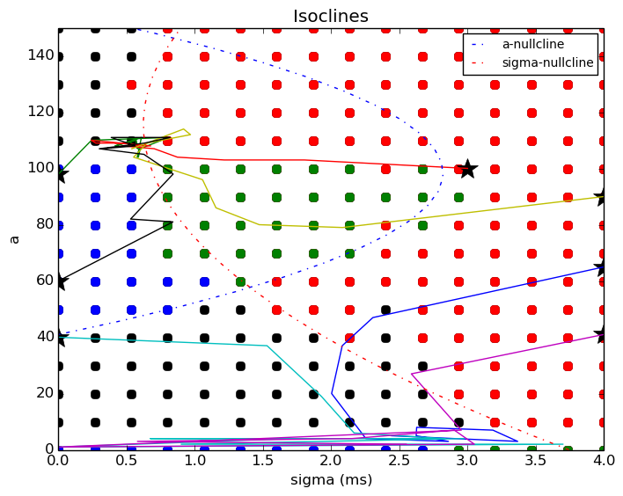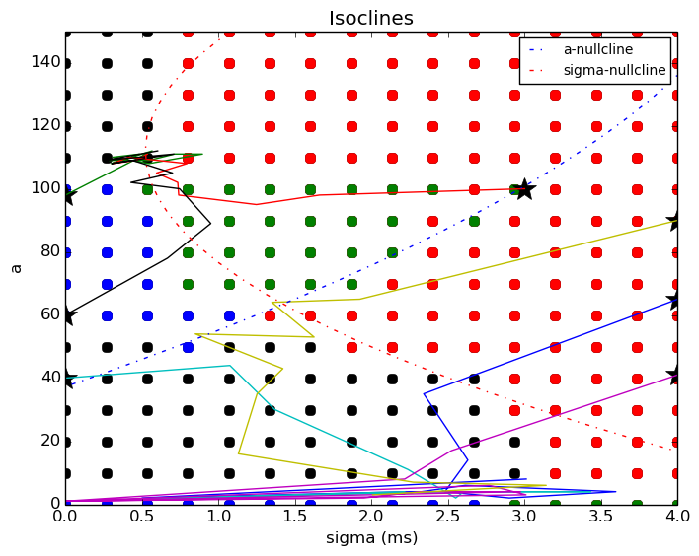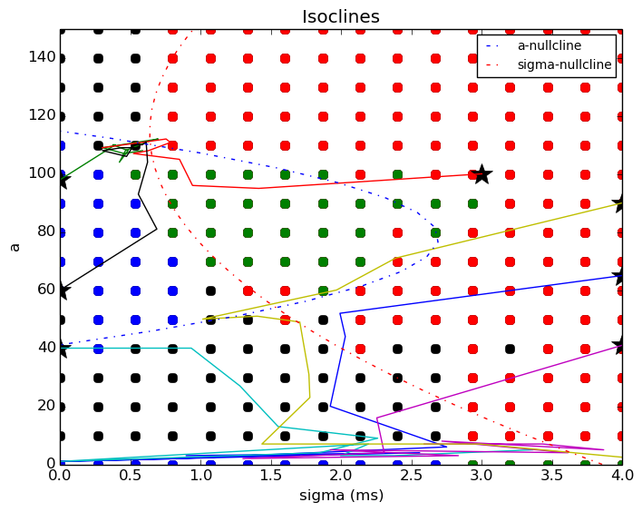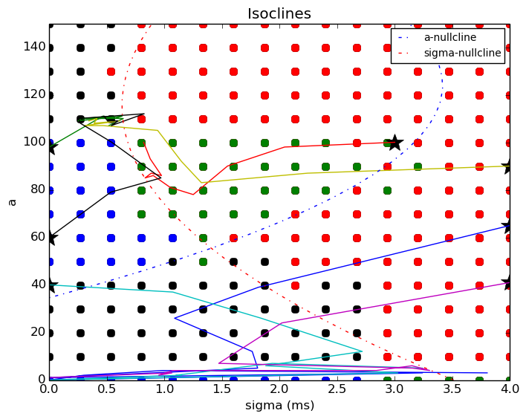
6. Below plot shows the change in fixed points with changing rate of inhibition: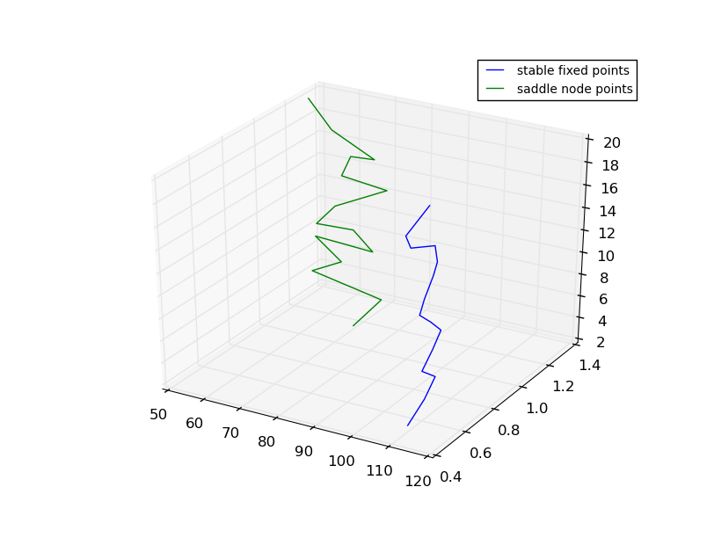
7. It is seen that inhibition rate change from 2 Hz to 20 Hz hasn’t affected the nature of fixed points. It could be that greater amount of inhibition will affect which can be achieved by increasing the proportion of inhibitory neurons or by further increasing the rate of inhibition.